Name - Gaurang A Raorane Div - D15A Roll no - 49

**Experiment - 1**

**Aim:-** Cryptography in Blockchain, Merkle root Tree Hash

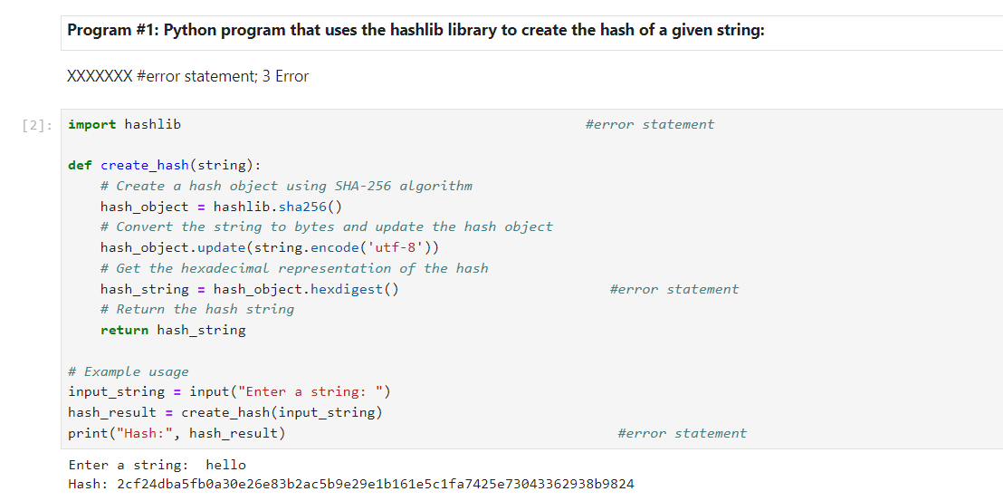

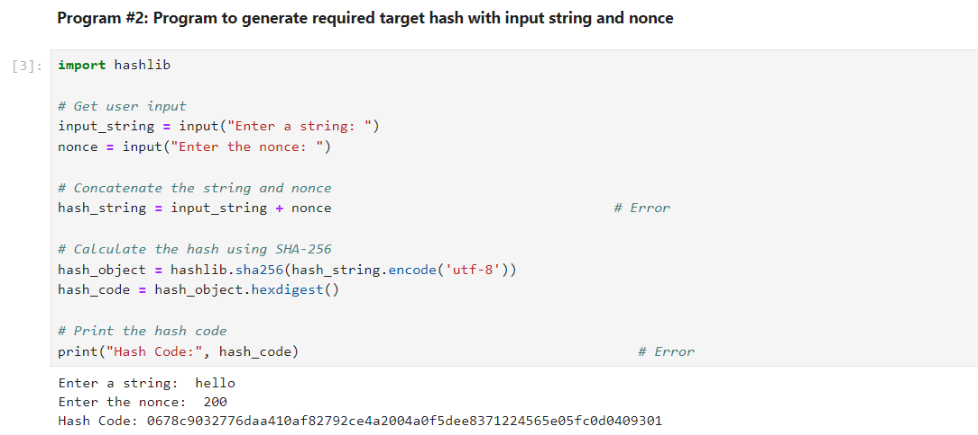

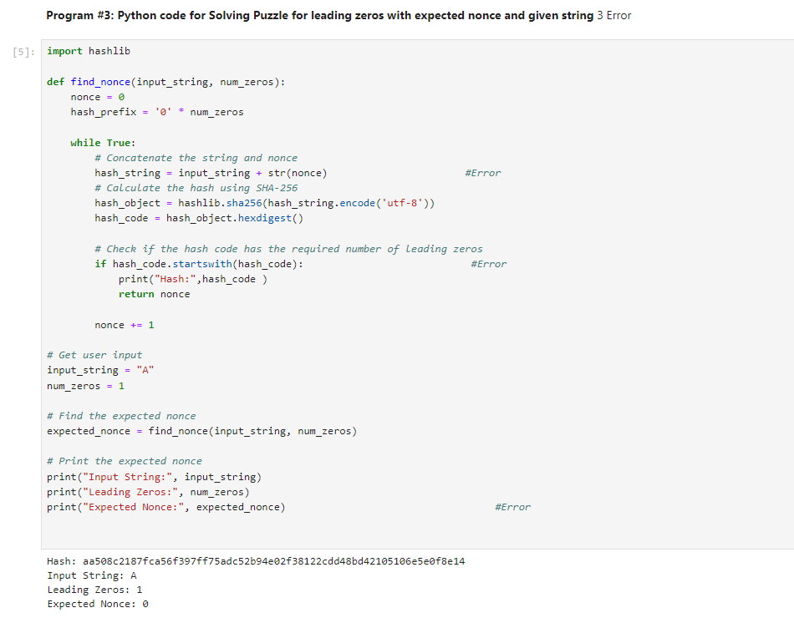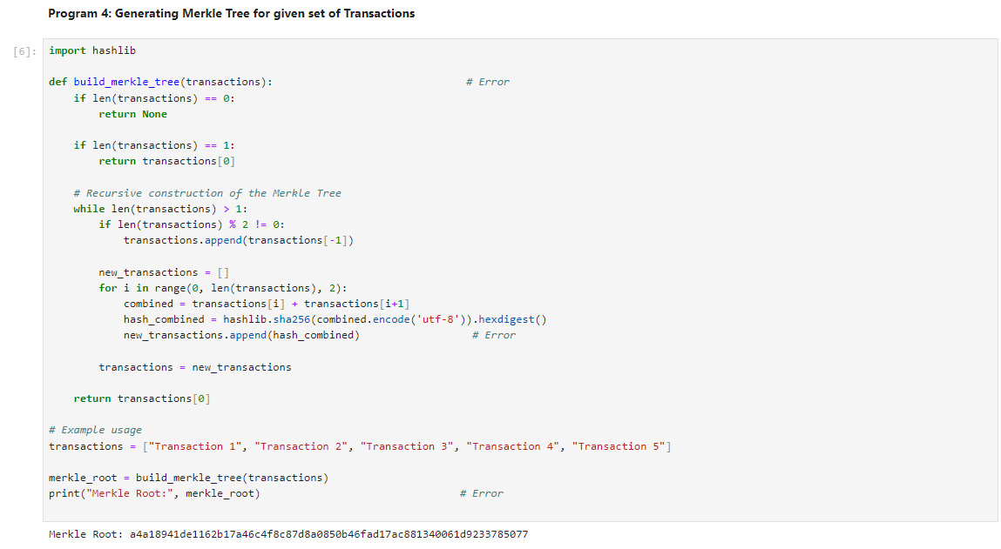Conclusion :- In this experiment we understood the construction of a Merkle Tree Root Hash involves iterative hashing individual transactions to form a tree structure and syntactical errors were fixed.